1. Create a comparison table listing the main differences between DDR3, DDR4, and DDR5 RAM, including speed, voltage, and typical use cases.

Feature | DDR3 | DDR4 | DDR5
Speed | 800 - 2133 MT/s | 2133 - 3200 MT/s | 4800 - 8400 MT/s
Voltage | 1.5V (1.35V for DDR3L) | 1.2V | 1.1V
Data Rate | Up to 17 GB/s | Up to 25.6 GB/s | Up to 67.2 GB/s
Memory Density | Up to 8 GB per module | Up to 32 GB per module | Up to 64 GB per module
Typical Use Cases | Basic computing, older systems | Gaming, mainstream PCs, workstations | High-end gaming, AI, data centers

2. Open your laptop or desktop (with power disconnected), locate the RAM slots, and take a clear photo of the installed RAM module. Reinstall the RAM module and verify that your system boots up successfully
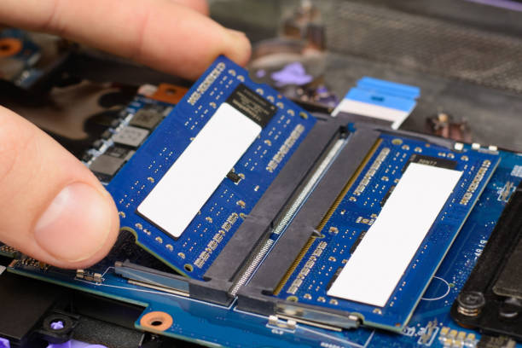
3. List three key differences between HDD, SSD, and NVMe storage types, and for each, name one app or use case (from apps you use daily) that would benefit most from that storage type.

Hard Disk Drive (HDD)
- Key Difference 1 (Speed): HDDs rely on spinning magnetic platters and mechanical read/write arms. speeds of 80-160 MB/s
- Key Difference 2 (Durability): Less durable. Because of
their physical moving parts
- Key Difference 3 (Cost & Capacity): They offer the most affordable cost per gigabyte, easily providing huge bulk storage capacities

Solid State Drive (SSD)
- Key Difference 1 (Speed): SSDs use NAND flash memory chips with no moving parts. They are much faster than HDDs, typically capping out at around 500-550 MB/s
- Key Difference 2 (Durability): Highly shock-resistant
- Key Difference 3 (Power & Noise): Silent operation and generally lower power consumption compared to an HDD

Non-Volatile Memory Express (NVMe)
- Key Difference 1 (Speed): NVMe is the fastest storage technology available read speeds ranging from 3,500 MB/s to well over 7,000 MB/s
- Key Difference 2 (Form Factor): They typically come in the compact M.2 form factor, which is small, sleek, and takes up virtually no space
- Key Difference 3 (Latency): extremely low latency for complex tasks.

4. Remove the storage drive (HDD or SSD) from your system, take a photo of the connector type (SATA, M.2, or NVMe), and reinstall the drive. Confirm that your device recognizes the storage after reassembly.

